Name Surname[1], Name Surname[2], (Font 12 Times New Roman, italics)

A concise title of the article that should not contain abbreviations, symbols or special characters(Font 14 Times New Roman, Bold)

Abstract

Type or paste your abstract here. It should contain all the essential information about paper: goals, the material and methodology, main results and conclusions. **MAX 2 page** (Font 12 Times New Roman)

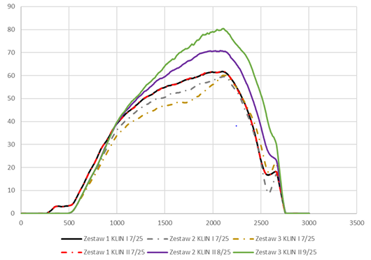

Fig.1 Figure/graph/photo (Font 12 Times New Roman)

**Acknowledgement** may include supporting grants, co-operations, and so forth. For examples: “The authors would like to thank Mr. XYZ for recording the experimental data”; “The authors are grateful to the ABC University, for the financial support granted to cover the publication fees of this research article”. Funding (financial support) – you can add, if necessary (Font 12 Times New Roman, italics)

**References** (Font 12 Times New Roman, italics)

[1] Duan H.L., Wang J., Karihaloo B.L., Theory of elasticity at the nanoscale, Advances in Applied Mechanics, 2008, 143, 1-68.

[2] Eremeyev V.A., Rosi G., Naili S., Surface/interfacial anti-plane waves in solids with

surface energy, Mechanics Research Communications 2016, 74, 8-13.

[3] Eremeyev V.A., Rosi G., Naili, S., Transverse surface waves on a cylindrical surface

with coating, International Journal of Engineering Science, 2020, 147, 103188.

1. Department or Faculty, University, Street, City, Country, email
2. Department or Faculty, University, Street, City, Country, email